Showing Messages on the Screen and Making a New Line (8086 Assembly)

1. Objective
In this lab, I wrote a small assembly program that prints three lines on the screen: my first name, my last name and my blood group. I also learned how to move the cursor to a new line between the messages.

2. Tools Used
- Code editor (VS Code) to write the .asm file
- TASM (Turbo Assembler) to assemble the code

3. Basic Idea
A computer cannot understand normal English words, so we write the program in assembly language. Assembly is a simple step above machine code. Each line tells the processor to do one small job.
To print something on the screen, we use DOS. We put a number in the AH register to say which job we want, and then we call INT 21H. The two jobs I used are:
- AH = 9 : print a full string (the string must end with a $ sign)
- AH = 2 : print one single character that is kept in the DL register
- AH = 4CH : stop the program and go back to DOS

4. How I Made the Messages (msg, msg1, msg2)
First, I made three messages in the .DATA part. Each one is a string with the db (define byte) command. I ended each string with a $ sign, because DOS needs the $ to know where the text stops.
msg db 'Fast Name : M M Samiul $'
msg1 db 'Last Name : Haque$'
msg2 db 'Blood Group : B + $'

- msg keeps the first name line.
- msg1 keeps the last name line.
- msg2 keeps the blood group line.
Before printing, the program must know where the data is kept. So I started the code with these two lines:
MOV AX, @DATA
MOV DS, AX

The first line takes the address of the data part and puts it in AX. The second line moves it into DS (the data segment register). We cannot move it straight into DS, so we use AX in the middle.

5. How I Printed Each Message
To print a message, I used the same three lines every time. Only the name of the message changes.
MOV AH, 9 ; job number 9 = print string
LEA DX, msg ; put the address of msg in DX
INT 21H ; ask DOS to do the job

For the second and third lines, I just changed msg to msg1 and msg2.

6. How I Made a New Line
If I print msg and then msg1 directly, both will come on the same line. To fix this, I printed two special characters between them:
- 0DH (Carriage Return) : moves the cursor back to the start of the line
- 0AH (Line Feed) : moves the cursor one line down
Together they work like pressing the Enter key. I used AH = 2 to print one character at a time from DL:
MOV AH, 2
MOV DL, 0DH ; carriage return
INT 21H
MOV DL, 0AH ; line feed
INT 21H

I wrote this new line block two times: once after msg and once after msg1. I did not add it after msg2, because that is the last message.

7. Full Code
This is the complete program.
.MODEL SMALL
.STACK 100H
.DATA
msg db 'Fast Name : M M Samiul $'
msg1 db 'Last Name : Haque$'
msg2 db 'Blood Group : B + $'
.CODE
MAIN PROC
; Initialize data segment
MOV AX, @DATA
MOV DS, AX

; Display msg (First Name line)
MOV AH, 9
LEA DX, msg
INT 21H

; New line
MOV AH, 2
MOV DL, 0DH ; carriage return
INT 21H
MOV DL, 0AH ; line feed
INT 21H

; Display msg1 (Last Name line)
MOV AH, 9
LEA DX, msg1
INT 21H

; New line
MOV AH, 2
MOV DL, 0DH
INT 21H
MOV DL, 0AH
INT 21H

; Display msg2 (Blood Group line)
MOV AH, 9
LEA DX, msg2
INT 21H

; Exit program
MOV AH, 4CH
INT 21H
MAIN ENDP
END MAIN

This is the screenshot of my code in the editor:
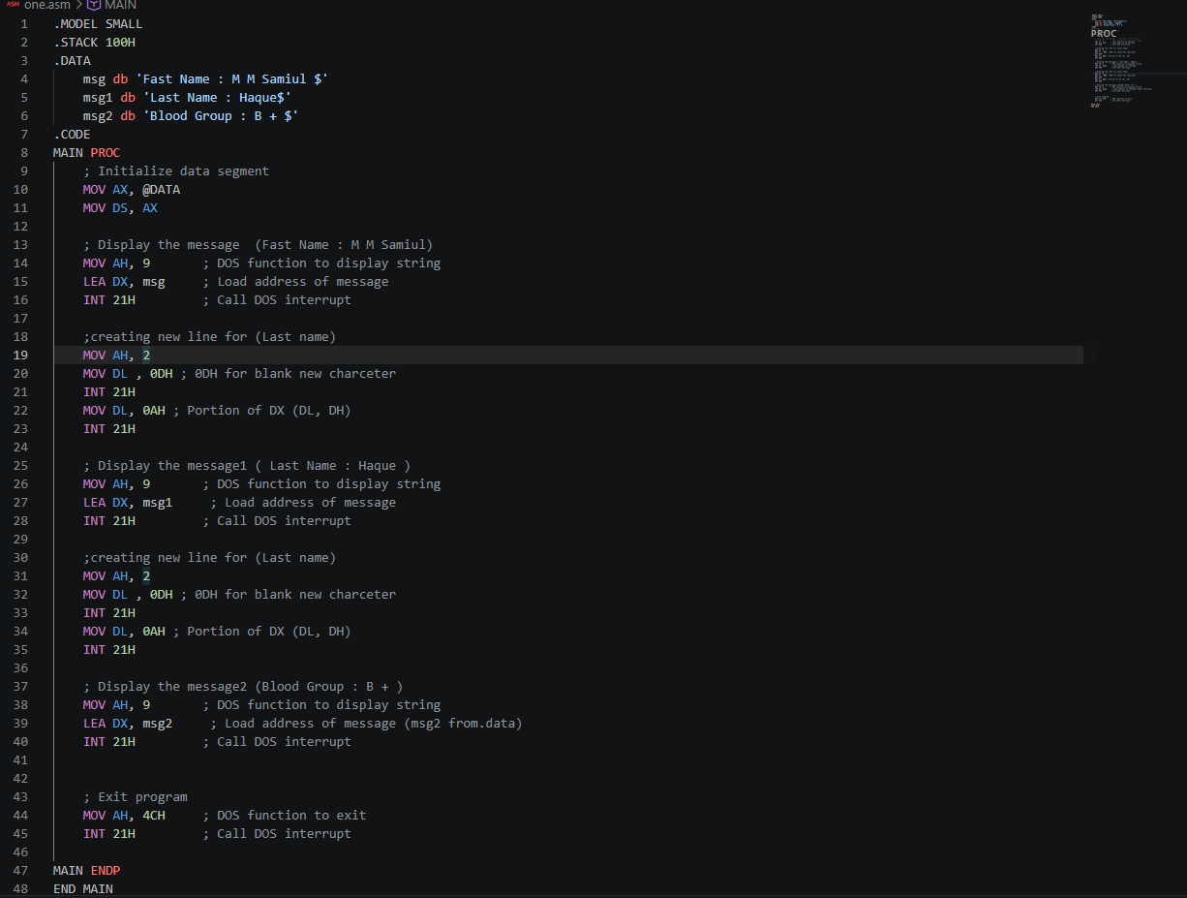
Figure 1: Assembly code in the editor

8. Output
The program ran without errors and printed my three lines, each on its own line.
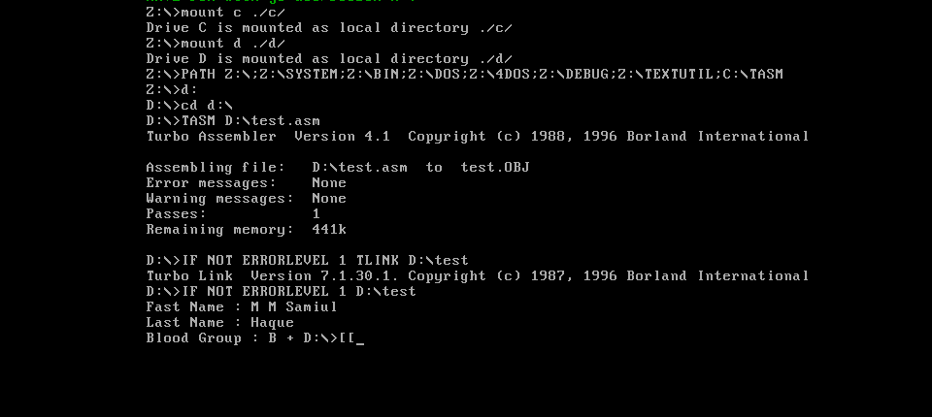
Figure 2: Output of the program

9. How to Handle Troubleshooting
- Weird symbols or no text on the screen: Check that MOV AX, @DATA and MOV DS, AX are written before the first print.
- Text keeps printing past the message: You forgot the $ at the end of the string.
- Two messages come on the same line: Add the new line block (0DH and 0AH) between them.
- File not found: Check the file name and make sure the .asm file is saved in the folder you are working in.
- Cursor stays on the same line as the DOS prompt after the output: Add one more new line block after the last message, before the exit code.

10. Conclusion
In this lab, I learned how to store text in the data segment, how to print a string with INT 21H and AH = 9, and how to make a new line using 0DH and 0AH. The program worked and printed my first name, last name and blood group on three separate lines.

